|  |
| --- |
| Identifying Irish Land Border Crossing Points Using OpenStreetMap Spatial Data Sets  Sean O’Riogain  September 2019 |
|  |

# Project Overview

## Background

During the run-up to the (latest) Brexit deadline of 31st October 2019, I was interested in determining, as accurately as possible, the number and location of crossing points on the land border between the Republic of Ireland and Northern Ireland.

A Google search led me to the map on the following website which was published in 2018 by the Irish Times:

* <https://www.irishtimes.com/news/world/brexit/borderlands/the-border>

which, in turn, was based on earlier mapping work done by the ‘Border Roads to Memories and Reconciliation’ project that was initiated in 2012 and is published on the following website:

* <http://www.borderroadmemories.com/>

This piece of research prompted me to use the skills I had acquired during Maynooth University’s Higher Diploma in Data Analytics course (2018-19) to produce my own map of the border crossing points and to compare the results achieved by my project with those published on the Irish Times website referred to above.

## Objectives

The objectives of this project were to:

1. Use the relevant OpenStreetMap spatial data sets to produce an accurate map of all crossing points on the land border between the Republic of Ireland and Northern Ireland.
2. Compare the results achieved with those documented in the Irish Times website referred to above.

## Tools Used

The following tools were used during the course of this project:

1. QGIS Version 3.4.11 (Madeira);
2. pgAdmin3 LTS by BigSQL Version 1.23.0b;
3. PostgresSQL Version 10.5;
4. PostGIS Version 2.5.0 r16836;
5. Structured Query Language (SQL)
   * This was used to analyse, manipulate (where necessary) and create the data needed by this project.
   * You can download this project’s SQL file (Brexit.sql) from this project’s GitHub repository which you can access using this link: <https://github.com/oriogain/Identifying-Irish-Land-Border-Crossing-Points-Using-OpenStreetMap-Spatial-Data-Sets>.

## Data Sources

The following data sources were used during this project;

1. QGIS QuickMapServices plugin (for the ‘OSM Standard’ background map);
2. OpenStreetMap road network data for Ireland and Northern Ireland
   * downloaded in ESRI shape file format (gis_osm_roads_free_1.shp) in this zip file: <https://download.geofabrik.de/europe/ireland-and-northern-ireland-latest-free.shp.zip>;
3. OpenStreet|Map boundary data for the Republic of Ireland
   * Downloaded in ESRI shape file format (Ireland_AL2.shp) in zip file exportedBoundaries_shp_levels_water_20190809_181605.zip from this website: <https://wambachers-osm.website/boundaries/>;
4. Irish Times border crossing point data
   * kindly provided by Dr Peter Mooney of Maynooth University in ESRI shape file format (IrishTimesBorderCrossings.shp) and available for download in this project’s GitHub repository which you can access using this link: <https://github.com/oriogain/Identifying-Irish-Land-Border-Crossing-Points-Using-OpenStreetMap-Spatial-Data-Sets>.

## Approach

The following approach was adopted for this project:

1. On a suitable PC (server=localhost), create a database schema (called brexit) for the exclusive use of this project in a new PostgreSQL database (called oriogain) and enable PostGIS functionality (extension) for it.
2. Download the zip files containing required spatial data sets using the links provided in the Data Sources section of this document above and unzip (extract) their contents.
3. Create a new QGIS project (called Brexit) and connect it to the database created by step 1 above.
4. Set the background map to ‘OSM Standard’ and zoom in to Ireland (using data source 1 above).
5. Import OSM’s road network mapping data for Ireland (using data source 2 above).
6. Overlay the OSM background map layer with the Republic of Ireland boundary map (using data source 3 above).
7. Convert the Republic of Ireland boundary polygon map layer to a linestring map layer.
8. Create the border crossing point data based on the intersection of the spatial data objects underlying the layers created by the previous 2 steps.
9. Analyse the border crossing point data created by the previous step for quality issues and take the appropriate corrective action.
10. Create a new crossing point map layer using the data output by the previous step, overlaying those layers referred to in steps 4 and 7 (in increasing order of precedence).
11. Create a new crossing point map layer to highlight the main crossing points mapped by the previous step.
12. Overlay the layer created by the previous step with one created by importing the Irish Times border crossing point data (using data source 4 above).
13. Create 2 database views and associated map layers to highlight the differences (novelties) in crossing point map layers created by previous 2 steps.
14. Analyse the crossing point differences identified by the previous step.
15. Summarise the findings of this project.

## Outcome

The outcome of this project can be summarised as follows:

1. This project identified a total of 325 border crossings of which 210 are the most significant ones.
2. The remaining 115 can be categorised as service roads (cul-de-sacs), tracks, paths etc., at least some of which may be of interest to smuggling interdiction operations post Brexit.
3. The Irish Times map identified a total of 207 (still open) border crossings (almost all of which are in the significant category as defined by this project).
4. The results achieved by this project are in close agreement with those published by the Irish Times, having 203 of its 207 border crossings in common (despite having slightly different coordinates for their respective crossing points).

Please refer to the final section of this document for a more detailed review of the findings of this project.

# Project Details

The following subsections provide the detailed instructions for implementing each step in the project approach (as outlined previously in this document) with supporting screen shots.

## Creating a PostGIS Database Schema

On my laptop (server=localhost), I created a database schema (called brexit) for the exclusive use of this project in a new PostgreSQL database (called oriogain) and enabled PostGIS functionality (extension) for it.

However, the instructions for doing this are outside the scope of this document.

## Downloading the Required Data Sets

Do this as follows:

1. Download the zip files containing the ESRI shape files for the roads network, the national boundary (including the border), and the Irish Times border crossing points using the links for data sources 2, 3 and 4, respectively, provided in the Data Sources section above.
2. Unzip (extract) the contents of those 3 zip files.

At which point, the contents of the target directory for this activity should look like the following:

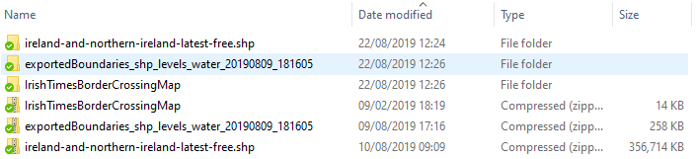

## Creating the QGIS Project

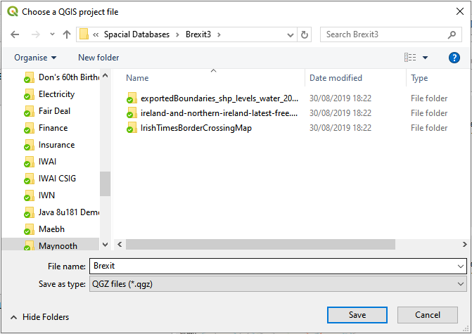

Do this as follows:

1. Launch QGIS.
2. Project>Save.
3. Enter ‘Brexit’ as the file name and click on the ‘Save’ button as shown on the right.

## Creating the Background Map Layer

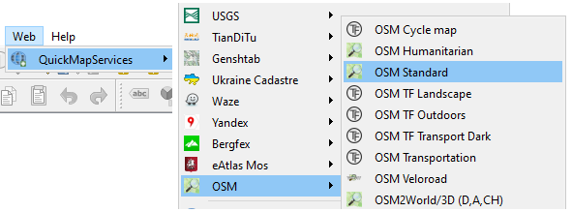

Do this as follows:

1. Web>QuickMapServices>OSM>OSM Standard (as shown on the right).
2. Zoom in to Ireland.

At which point, the relevant part of the QGIS canvas should look like the screen shot below.

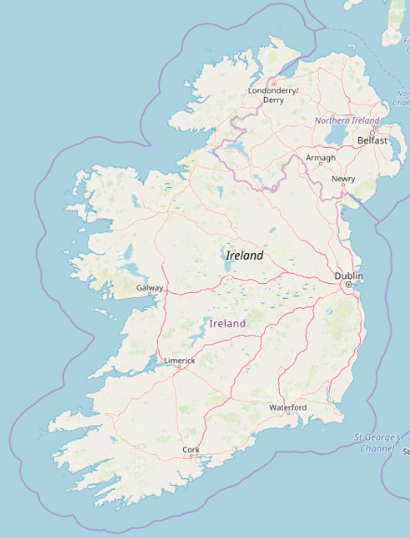

## Creating the Roads Network Map Layer

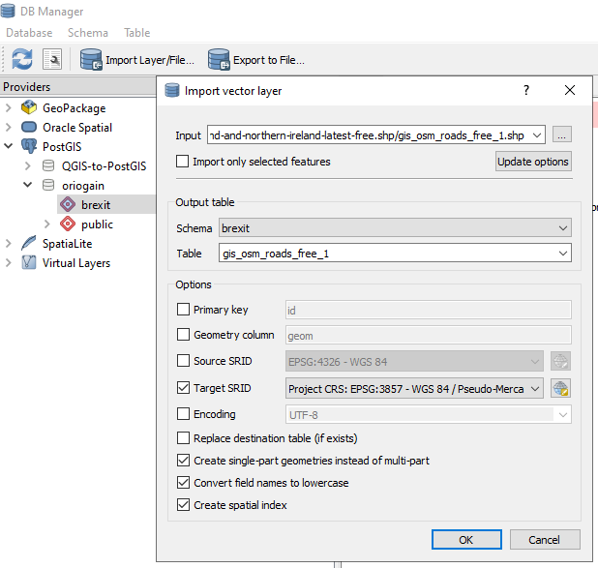

Do this as follows:

1. Database>DB Manager>Import Layer/File
2. For the ‘Input’ prompt use the … button to select the gis_osm_roads_free_1.shp file in the folder into which it was unzipped (extracted).
3. Set the Target SRID to 3857 (to match that of the OSM Standard background map layer).
4. Tick the ‘Create single-part geometries…’ tick box.
5. Tick the ‘Convert field names…’ tick box (just in case).
6. Tick the ‘Create spatial index’ tick box.
7. Click on the ‘OK’ button (see the screen shot on the upper right).

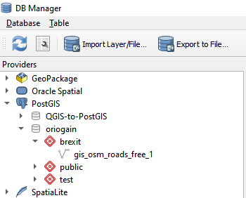

* + As a pretty large spatial data set is involved, this import could take a couple of minutes to complete.

1. Expand the project’s schema to confirm that the expected database table has been created successfully (as shown in the screen shot on the lower right).

Note that, as the road network is already depicted on the OSM Standard background map, we will not be adding this data set as a layer on our mapping canvas. But we will be using it to identify the border crossing points later in this document (using SQL).

## Creating the ROI Boundary (Border) Map Layer

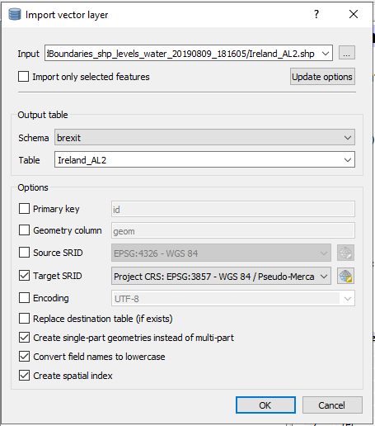

Do this as follows:

1. Database>DB Manager>Import Layer/File
2. For the ‘Input’ prompt use the … button to select the Ireland_AL2.shp file in the folder into which it was unzipped (extracted).
3. Set the Target SRID to 3857 (to match that of the OSM Standard background map layer).
4. Tick the ‘Create single-part geometries…’ tick box.
5. Tick the ‘Convert field names…’ tick box (just in case).
6. Tick the ‘Create spatial index’ tick box.
7. Click on the ‘OK’ button (see the screen shot on the upper right).
8. Expand the project’s databases schema.

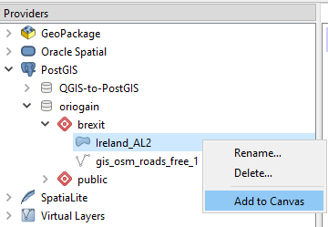

1. Right click on the database table that has just been created (Ireland_AL2).
2. Select the ‘Add to Canvas’ option (see screen shot on the lower right).
3. Return to the QGIS project window, at which point the map of Ireland on your QGIS palette should look like that shown in the screen shot below.

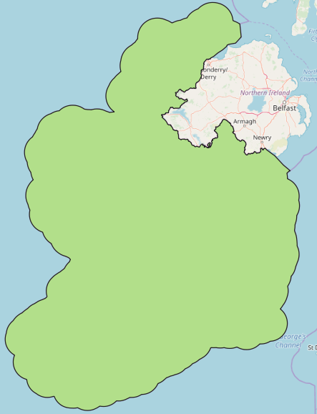

At this point, it should be noted that:

1. The new boundary map layer is a polygon.
2. We need to convert it to a linestring map layer (see the next section) before we can determine the (border crossing) points where the road network linestrings intersect it.
3. As this boundary includes Irish territorial waters, it means that those intersections only occur at the land border (which is precisely what we want). Otherwise, we would also be getting a very large number of unwanted intersection points where the road network linestrings intersect (or touch) the Republic of Ireland’s coastline.

## Converting the ROI Boundary Map Layer

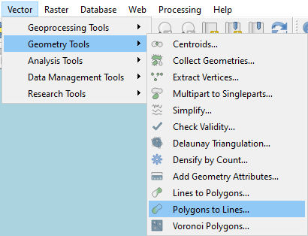

Do this as follows:

1. Select the Ireland_AL2 (boundary polygon) layer in the Layers pane.
2. Vector>Geometry Tools>Polygons to Lines (as shown in the 1st screen shot on the right).
3. Accept the default settings and click on the ‘Run’ button (as shown in the 2nd screen shot on the right).
4. Right-click on the ‘Lines’ layer that was created by the previous step in the Layers pane and select the Export>Save>Features As option, ‘ESRI Shapefile’ as the format, use the ‘…’ button to set the target file name as ‘Ireland_AL2_Boundary_Line.shp’, and click on the ‘OK’ button (as shown in the 3rd screen shot on the right).

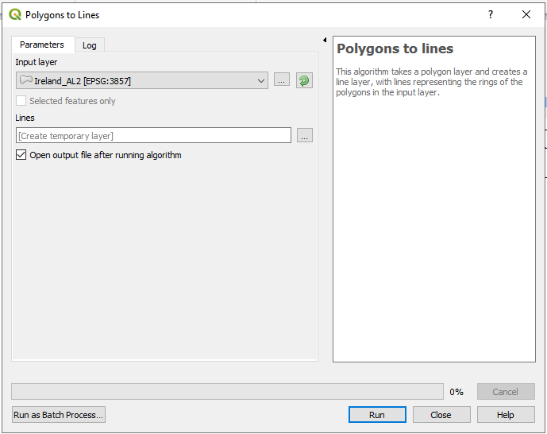

1. Database>DB Manager>Import Layer/File.
2. For the ‘Input’ prompt use the ‘…’ button to select the Ireland_AL2_Boundary_Line.shp file in the folder in which it was created by step 4 above.
3. Tick the ‘Create single-part…’ tick box.
4. Tick the ‘Convert field names…’ tick box (just in case).
5. Tick the ‘Create spatial index’ tick box.
6. Click on the ‘OK’ button (see the 4th screen shot on the right).
7. In the Providers pane, right-click on the Ireland_AL2_Boundary_Line table that was created in the project’s database schema by the previous step and select the ‘Add to Canvas’ option.

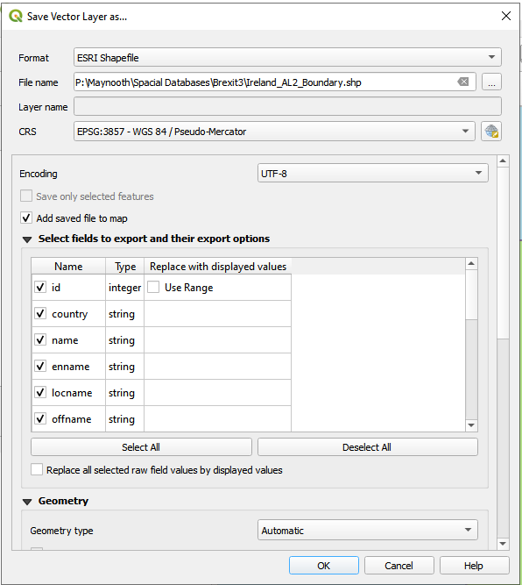

1. Reverting to the main QGIS window, right-click on the Ireland_AL2_Boundary_Line layer that was created by the previous step, select the ‘Properties’ option and change the Color setting in the Symbology tab to black.
2. Right-click on the (now redundant) Lines and Ireland_AL2_Boundary layers, in turn, and select the ‘Remove Layer’, leaving the relevant section of the project’s mapping canvas looking like that in the screen shot below.

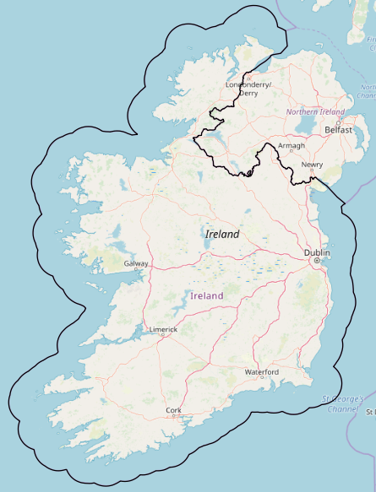

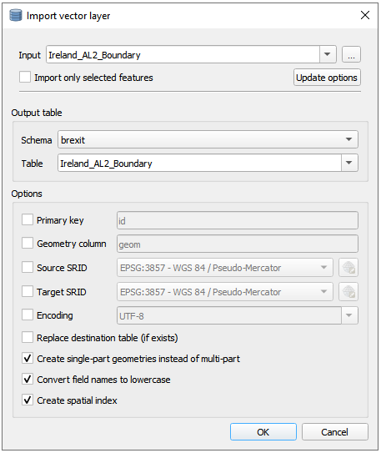

## Creating the Project’s Border Crossing Point Data

The project’s database schema now contains 3 tables (as shown in the 1st screen shot on the right).

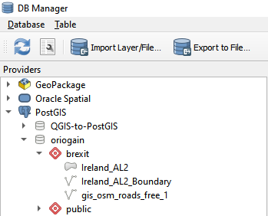

To create a QGIS layer that represents the border crossing points, we must firstly create a database table that contains the details of where the Irish road network linestrings represented by the contents of the database table called gis_osm_roads_free_1 intersect with the border linestring represented by the contents of the database table called Ireland_AL2_Boundary.

To do that, we will use PostgreSQL’s PGAdmin tool to write and execute the required SQL statements, including the relevant PostGIS function, needed to determine the layer intersection (border crossing) point locations.

Here are the instructions for doing this:

1. Launch PGAdmin.
2. Tools>Query tool.
   * Open this project’s SQL file (Brexit.sql) which you can download from this project’s GitHub repository using the following link: <https://github.com/oriogain/Identifying-Irish-Land-Border-Crossing-Points-Using-OpenStreetMap-Spatial-Data-Sets>.
3. Select and execute the following SQL statements in that file (which take about 5 minutes to complete on my laptop):

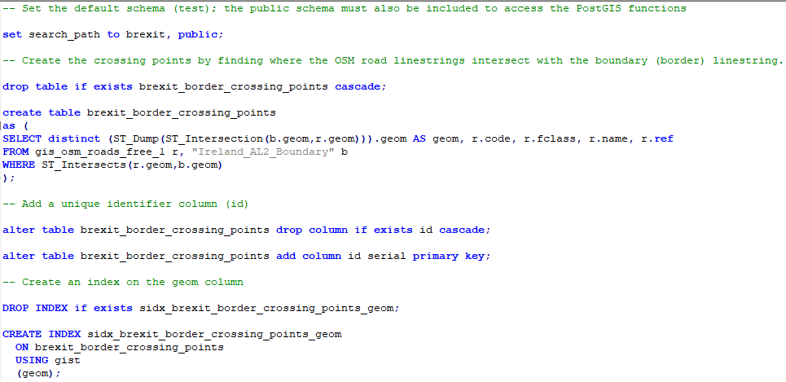

1. To confirm that this has produced the expected results (i.e. that a database table called brexit_border_crossing_points containing 438 rows has been created), select and execute the SQL statement shown in the screen shot on the right and check that the result achieved is the same as that shown in the screen shot below it.

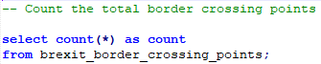

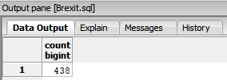

## Analysing the Project’s Border Crossing Point Data

The following data quality issues were identified with the contents of the brexit_border_crossing_points table during the course of this project:

1. 47 rows have unexpected values (greater than 50 characters in length) in the geom column whose presence prevents the border crossing points layer being created in QGIS.
   * Displaying their values using PostGIS’s ST_AsText function shows that they represent linestrings rather than points.
   * Upon further investigation, these data represent stretches of 3 different roads that follow the line of the border for short distances and, therefore, cannot be characterised as border crossing points.
   * The roads in question are Balloughry Road (on the Donegal-Derry border), Inver Road (on the Monaghan-Fermanagh border) and Rowan Road (on the Monaghan-Armagh border).
2. 120 rows with duplicate values in the geom column because some crossing roads are incorrectly treated as 2 separate roads with different ref values (e.g. the County Bridge road which is known as the B79 in Northern Ireland and the R173 in the Republic).
3. 2 rows (with different geom values) represent the points where both carriageways of the A1 road cross the border which incorrectly presents a single border crossing as 2 crossings (another type of duplication, effectively).
4. 2 rows represent where 2 sides of the Fitzpatrick Hardware site on the border north of Clones, Co, Monaghan, cross the border thereby incorrectly them as border crossings.

How to identify and deal with each of those anomaly types is described in the subsections that follow.

### Linestring ‘Crossing Points’

Use PGAdmin’s Query tool to identify these anomalies by selecting and executing the following SQL statement:

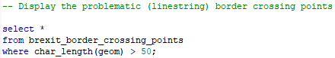

Here is an extract of the expected results:

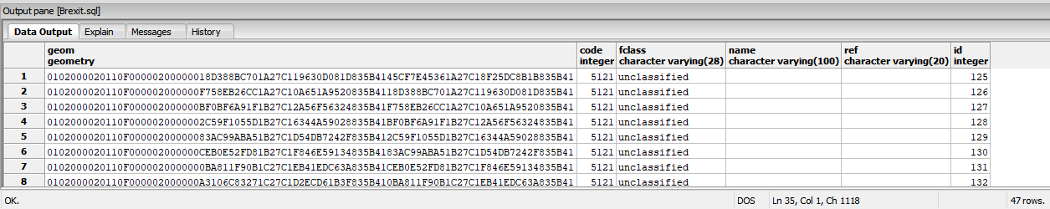

Delete these anomalies by selecting and executing the following SQL statement:

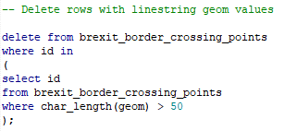

### Duplicate Crossing Points

Use PGAdmin’s Query tool to identify these anomalies by selecting and executing the following SQL statement:

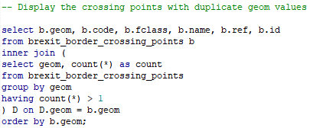

Here is an extract of the expected results:

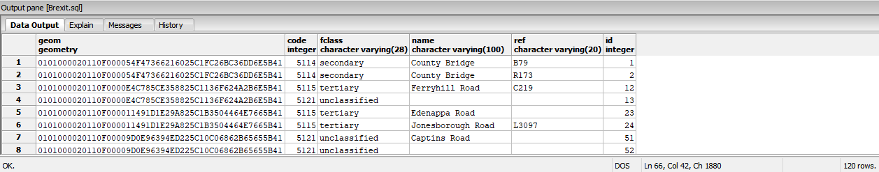

Delete the first row in each group of these anomalies by selecting and executing the following SQL statement:

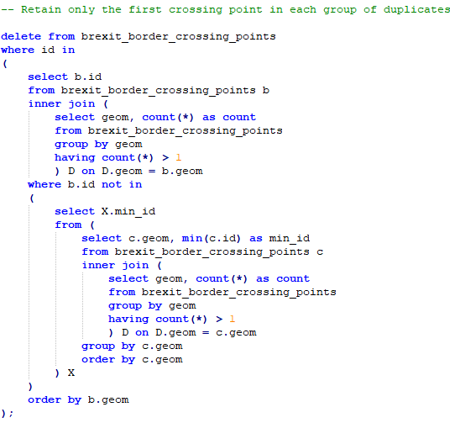

### Duplicate Crossing Points on A1 Dual Carriageway

Use PGAdmin’s Query tool to identify these anomalies by selecting and executing the following SQL statement:

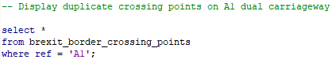

Here are the expected results:

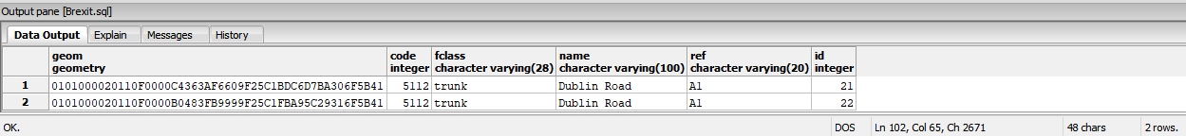

Delete one of these crossing points by selecting and executing the following SQL statement:

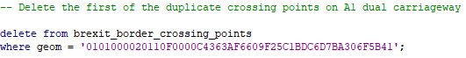

### Invalid Crossing Points in the Fitzpatrick Hardware Site

Use PGAdmin’s Query tool to identify these anomalies by selecting and executing the following SQL statement:



Here are the expected results:

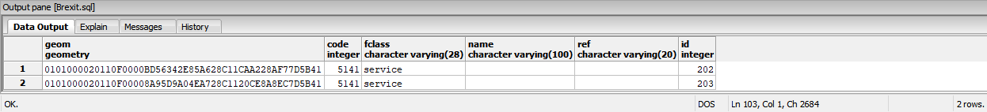

Delete these anomalies by selecting and executing the following SQL statement:



### Valid Crossing Points Summary

Use PGAdmin’s Query tool to count the remaining (valid) rows in the brexit_border_crossing_points table by selecting and executing the following SQL statement:

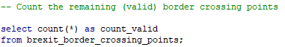

Here are the expected results:

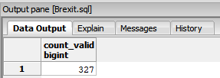

Break down the above row count by road class by selecting and executing the following SQL statement:

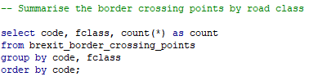

Here are the expected results:

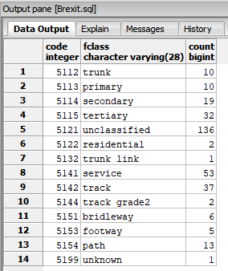

We can see from the above results that, of the 327 crossing points identified, the first 210 are the key ones (i.e. with a code value of less than 5141) while the remaining 117 are of limited consequence/interest (i.e. with a code value of 5141 or greater).

## Creating the Project’s Border Crossing Point Map Layer

At this stage, we can see in the 1st screen shot of the Providers pane of QGIS’s DB Manager component on the right that, while the brexit_border_crossing_points table is present, its geometry type is unknown (as indicated by the ‘?’ symbol). To rectify this situation, we will now export that table in ESRI shape file format and reimport it as follows:

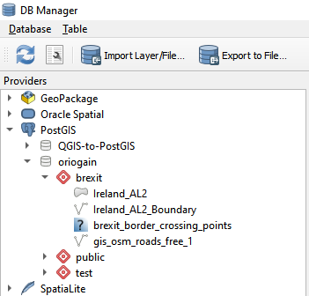

1. Select the brexit_border_crossing_points table;
2. Click on the ‘Export to File..’ option.
3. Select ‘ESRI Shapefile’ in response to the Format prompt (see the 2nd screen shot on the right).
4. For the ‘Save as’ prompt use the ‘…’ button to specify ‘brexit_border_crossing_points.shp’ as the target file in the project’s folder.
5. Click on the ‘OK’ button.
6. Click on the ‘Import Layer/File..’ option.
7. For the ‘Input’ prompt use the ‘…’ button to select the brexit_border_crossing_points.shp file in the folder in which it was created by step 5 above (see the 3rd screen shot on the right).

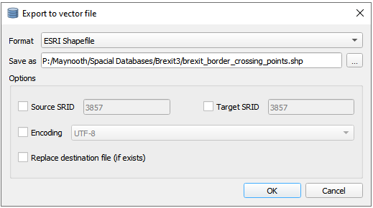

1. Tick the ‘Replace destination table…’ tick box.
2. Tick the ‘Create single-part…’ tick box.
3. Tick the ‘Convert field names…’ tick box (just in case).
4. Tick the ‘Create spatial index’ tick box.
5. Click on the ‘OK’ button.
6. In the Providers pane, right-click on the brexit_border_crossing_points table that was recreated in the project’s database schema by the previous step and select the ‘Add to Canvas’ option.
   * Note how its geometry type icon now indicates that it contains point data.
7. Reverting to the main QGIS window, right-click on the brexit_border_crossing_points layer that was created by the previous step, select the ‘Properties’ option and change the Color setting in the Symbology tab to yellow, leaving the relevant section of the project’s mapping canvas looking like that in the screen shot below.

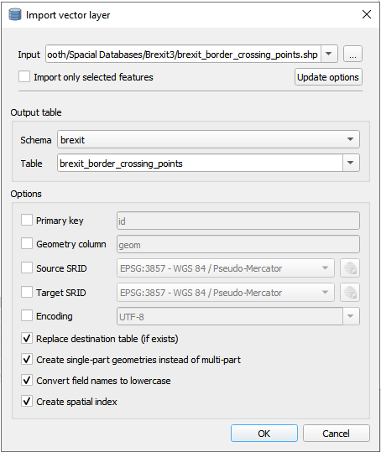

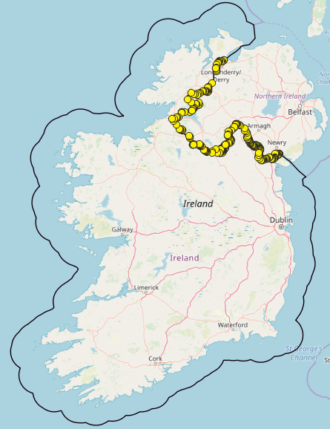

As the mapping layer created above shows all 327 crossing points, we will now create an additional layer to highlight the 210 key (main) crossing points as follows:

1. Use PGAdmin’s Query tool to highlight and execute the following SQL statement in this project’s SQL file:
2. Reverting to QGIS’s DB Manager window, right-click on the project’s database in the Providers pane, select the ‘Re-connect’ option, and expand the project’s database schema.

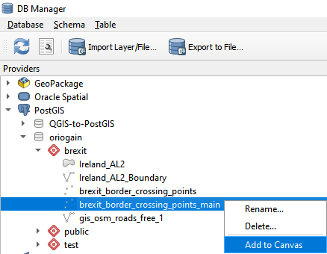

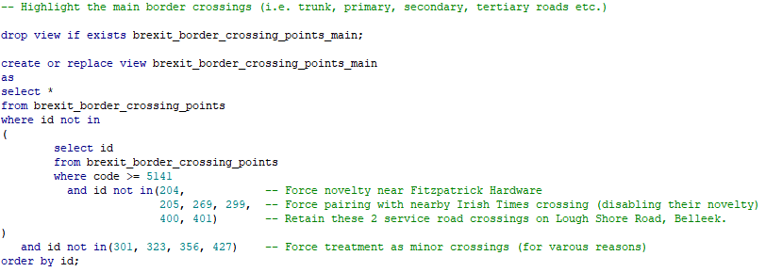

1. Right click on the database view called brexit_border_crossing_points_main (that was created by step 1 above) and select the ‘Add to Canvas’ option’ (as shown in the screen shot on the right).
2. In the Layers pane of the main QGIS window, select the newly-created brexit_border_crossing_points_main layer, select the Properties option and, in the Symbology tab, set the Color value to dark red and the Size to 4.00 - see the screen shot below for the results in the mapping canvas pane (having zoomed in).

## Creating the Irish Times Border Crossing Point Map Layer

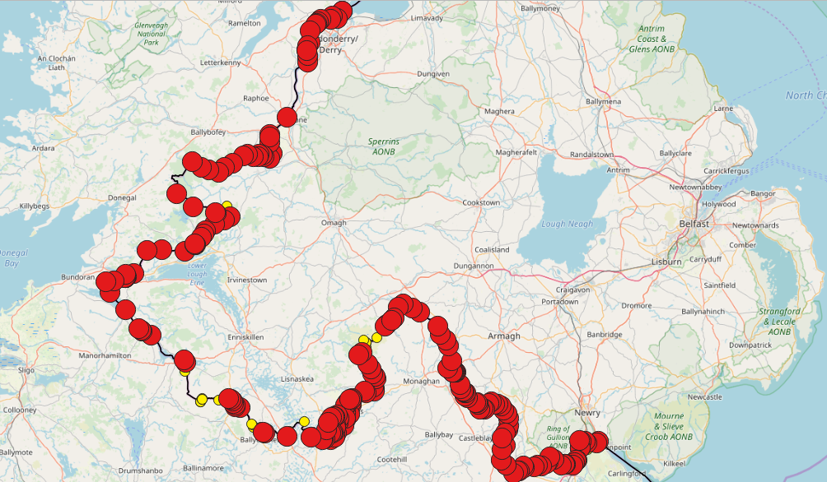

We will now overlay the project’s border crossings map (as illustrated in the previous screen shot above) with those identified on the map published by the Irish Times (see the details provided earlier in this document) as follows:

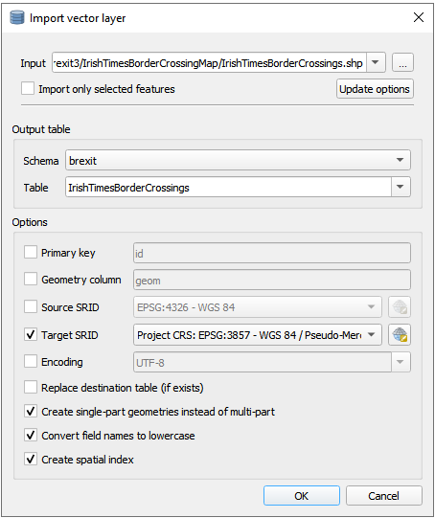

1. Switch to QGIS’s DB Manager window.
2. For the ‘Input’ prompt use the … button to select the IrishTimesBorderCrossings.shp file in the folder into which it was unzipped (extracted).
3. Set the Target SRID to 3857 (to match that of the OSM Standard background map layer).
4. Tick the ‘Create single-part geometries…’ tick box.
5. Tick the ‘Convert field names…’ tick box (just in case).
6. Tick the ‘Create spatial index’ tick box.

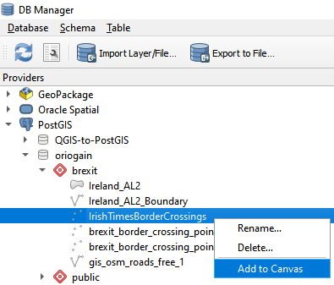

1. Click on the ‘OK’ button (see the screen shot on the upper right).
2. Expand the project’s databases schema.
3. Right click on the database table that has just been created (IrishTimesBorderCrossings).
4. Select the ‘Add to Canvas’ option (see screen shot on the lower right).
5. Return to the main QGIS project window, at which point the map of Ireland on your QGIS palette should look like that shown in the screen shot below, having selected the newly-created IrishTimesBorderCrossings layer, having selected the Properties option and set the Color setting to royal blue in the Symbology tab.

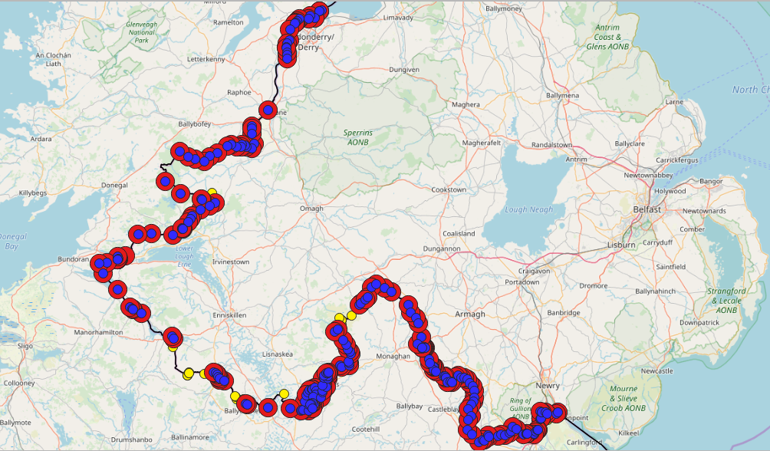

Note how the screen shot above shows that there appears to be an extremely high level of correspondence between the Irish Time’s crossing points (in royal blue) and the key crossing points identified by this project (in dark red).

## Creating the Difference (Novelty) Highlighting Map Layers

We will now take a closer look at the apparent level of correspondence between the 2 sets of border crossing points referred to above by seeking to identify where any differences arise and highlighting them on the project’s map as follows:

1. Use PGAdmin’s Query tool to highlight and execute the following SQL statements in this project’s SQL file:

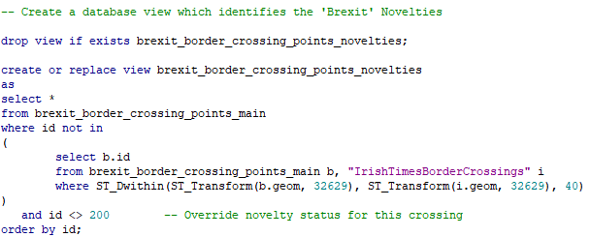

* + The database view created by the above SQL statements identifies crossing points in the key (main) crossing points detected by this project which are not within 40 meters of at least one of the Irish Times’ crossing points. (Selecting that distance was done through a process of trial and error.)

1. Use PGAdmin’s Query tool to highlight and execute the following SQL statements in this project’s SQL file:

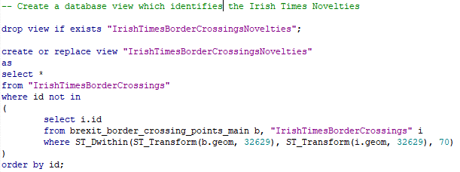

* + The database view created by the above SQL statements identifies Irish Times crossing points in the key (main) crossing points detected by this project which are not within 70 meters of at least one of main crossing points detected by this project. (Selecting that distance was done through a process of trial and error.)

1. Reverting to QGIS’s DB Manager window, right-click on the project’s database in the Providers pane, select the ‘Re-connect’ option, and expand the project’s database schema.
2. In the Providers pane, right-click on the brexit_border_crossing_points_novelties view that was created in the project’s database schema by step 1 above and select the ‘Add to Canvas’ option.
   * Note how its geometry type icon indicates that it contains point data.
3. Right-click on the IrishTimesBorderCrossingsNovelties view (that was created in the project’s database schema by step 2 above) and select the ‘Add to Canvas’ option.
   * Note how its geometry type icon also indicates that it contains point data.
4. Switch to the main QGIS project window whose Layers pane should now look like that shown in the 1st screen shot on the right.

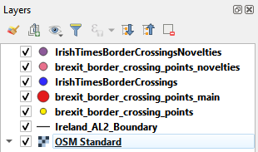

1. Right click on the IrishTimesBorderCrossingsNovelties layer, select the Properties option and, in the Symbology tab, change its Color setting to light blue and its Size setting to 6.00, and then click on the ‘OK’ button.
2. Right click on the brexit_border_crossing_points_novelties layer, select the Properties option and, in the Symbology tab, change its Color setting to pink and its Size setting to 6.00, and then click on the ‘OK’ button.

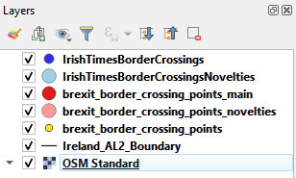

1. Drag both ‘novelties’ layers to reposition them immediately beneath the layer to which they refer (see the 2nd screen shot on the right for the required end result).

At this stage, the QGIS mapping pane should look like that in the screen shot below in which you should be able to see:

1. Minor crossing points identified by this project (in yellow).
2. Matching crossing points (in dark red with royal blue centre)
3. Irish Times novelty crossing points (in royal blue with a light blue halo).
4. This project’s novelty (main) crossing points (in dark red with a pink halo).

## Analysing the Border Crossing Point Differences (Novelties)

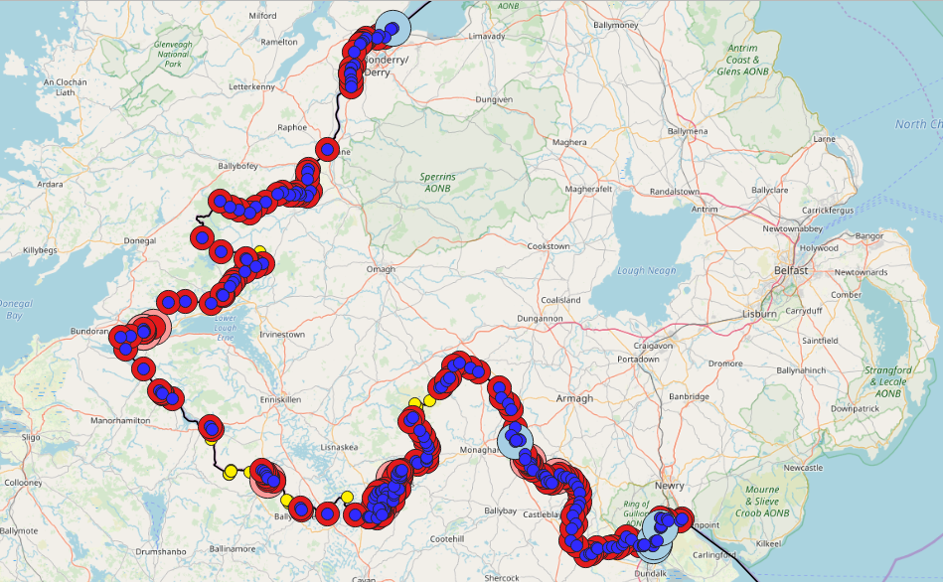

It the following 2 subsections we will take a closer look at the differences (novelties) between the border crossing points identified by both the Irish Times map and the main crossing points identified by this ‘Brexit’ project.

### Irish Times Novelties

These are the border crossing points identified by the Irish Time’s mapping exercise that were not identified during this project’s mapping exercise. We will now take a closer look at them as follows:

1. Use PGAdmin’s Query tool to highlight and execute the following SQL statement in this project’s SQL file:

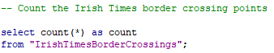

1. As shown the in the following screen shot, the results of this SQL statement tell us that a total of 208 border crossing points have been identified:

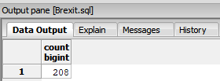

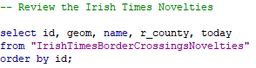

1. Highlight and execute the following SQL statement in this project’s SQL file:
2. As shown the in the following screen shot, the results of this SQL statement tell us that 5 such discrepancies exist:

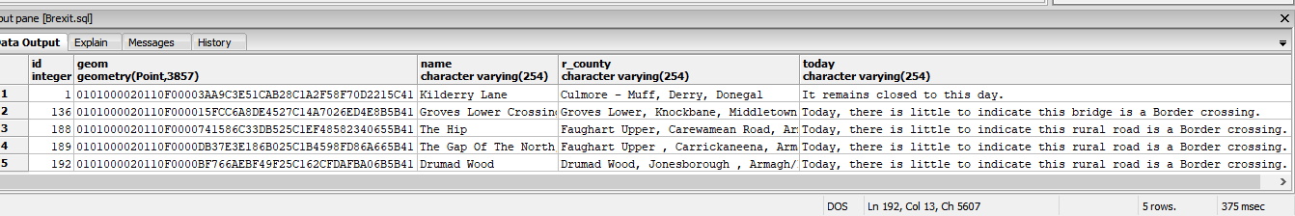

* + Note the comments in the today column above, in which at least one of them (the first one) is flagged as no longer being a usable border crossing.

1. The following screen shots provide a zoomed-in view of each of those anomalous crossing points (i.e. those in royal blue with a light blue halo) in this project’s map:

|  |  |  |
| --- | --- | --- |
| 1. id=1 (Muff, Co. Donegal) | 1. id=136 (Middletown, Co. Armagh) | 1. id=188 (Carewamean Rd., Co. Armagh) |
| 1. id=189 (Carrickaneena, Co. Armagh) |  | 1. id=192 (Jonesborough, Co. Armagh) |

Of the 5 anomalies illustrated above:

1. the first one (id=1) is no longer a border crossing and should not be included in any list of border crossings;
2. the second novelty crossing (id=136) was not picked up by this project because the road in question appears to straddle the border line at the location in question;
3. the remaining novelties (id=188, 189 & 192) appear to be caused by the Irish Times data having a different view - relative to OpenStreetMap - as to where exactly the border line is situated at the locations in question.

### This Project’s (‘Brexit’) Novelties

These are the main border crossing points identified by this project that were not identified included in the Irish Time’s border crossing mapping data. We will now take a closer look at them as follows:

1. Use PGAdmin’s Query tool to highlight and execute the following SQL statement in this project’s SQL file:

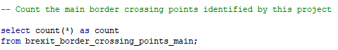

1. As shown the in the following screen shot, the results of this SQL statement tell us that a total of 212 (main) border crossing points have been identified:

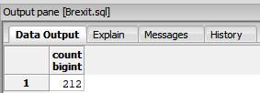

1. Highlight and execute the following SQL statement in this project’s SQL file:
2. As shown the in the following screen shot, the results of this SQL statement tell us that 9 such discrepancies exist:

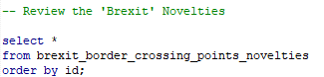

* + Note that 3 of the 9 anomalies are service roads which have been deliberately reclassified as main crossings, based on the route they take on the map, during this project.

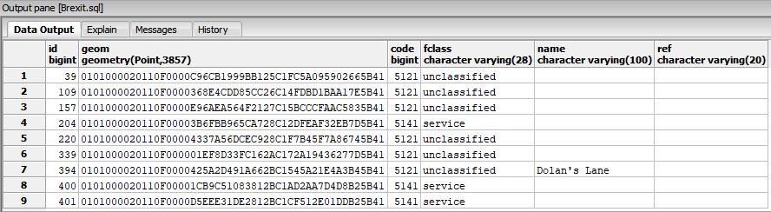

1. The following screen shots provide a zoomed-in view of each of those anomalous crossing points (i.e. those in dark red with a pink halo) in this project’s map:

|  |  |  |
| --- | --- | --- |
| 1. id=39 (Carrickbroad Road, Co. Louth) | 1. id=109 (Clay, Co. Armagh) | 1. id=157 (Rowan Road, Co. Armagh) |
| 1. id=204 (Fitzpatrick Hardware, Co. Monaghan) | 1. id=220 (Clonnestin, Co. Monaghan) | 1. id=339 (Swanlinbar, Co. Cavan) |
| 1. id=394 (Boa Island Road, Belleek, Co. Fermanagh) |  | 1. id=400 & 401 (Lough Shore Road, Belleek, Co. Fermanagh) |

Of the 9 anomalies illustrated above:

1. 2 of them (id=39 & 157) have appear to have tenuous claims of being genuine border crossings and, therefore, can be discounted;
2. the remaining 7 appear to be viable border crossings.

## Summarising the Findings of this Project

The findings of this project can be summarised by the following points:

1. This project has identified a total of 327 border crossings of which 212 have are classed as being key (main) ones;
2. 2 of those 212 main crossings have been discounted (see above), leaving a total of 325 of which 210 are the main ones;
3. The remaining 115 crossings can be categorised as service roads (e.g. driveways, cul-de-sacs etc.), paths, tracks etc.
4. Post Brexit, at least some of those 115 minor crossings identified by this project (represented by the yellow crossing points on the map) would need to be factored in by smuggling interdiction operations.
5. The Irish Times map identifies 208 crossings (almost of which fall into the ‘main’ category used by this project).
6. Of those 208 crossings, 1 has been discounted because it has been permanently closed (near Muff, Co. Donegal), leaving a total of 207 crossings.
7. Of those 207, 4 others are dubious ones if OpenStreetMap’s positioning of the border is accurate – but, erring on the side of caution, we cannot discount them at this stage.
8. Therefore, the delta in the count of main crossings between this project’s map and that published by the Irish Times is 3 (210-207).
9. That delta is due to 4 novelties in the Irish Time crossing point data and 7 novelties identified by this project (7-4=3).
10. The previous point means that both maps are in agreement for 203 of their 210/207 border crossings which lends credibility to the contents of both maps.
11. The previous point is further underlined by the fact that it is clear that both maps are based on independently-acquired, and slightly different, spatial data sets as illustrated by the screen shot below.

